- Created a bucket
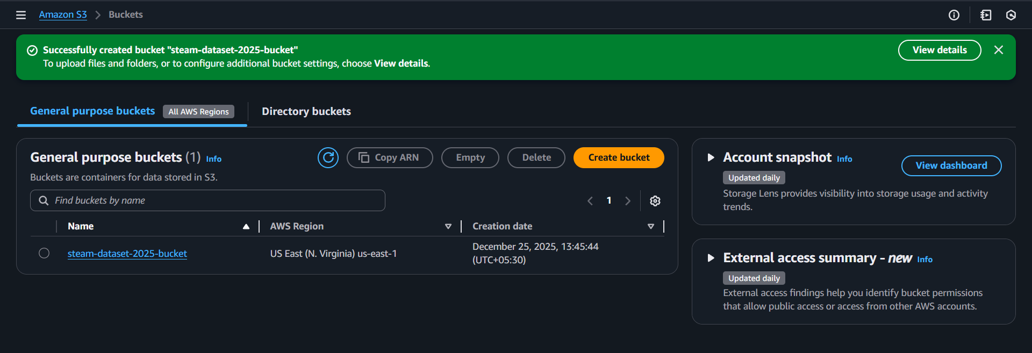
- Created EC2 t3.micro
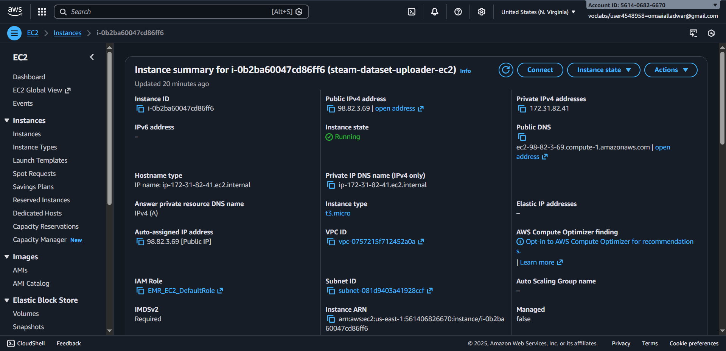
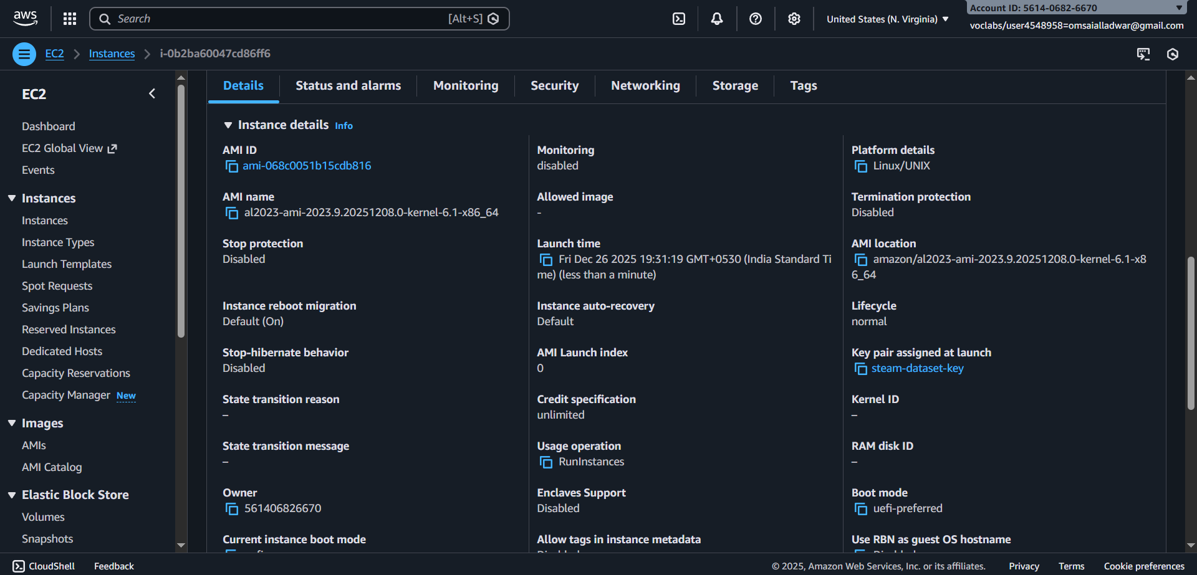
- Connected to mobaXterm
- Installed Python and pip on it
- Installed boto3, s3fs libraries
- Ran uploader_script.py
- The script transfer’s the dataset from Kaggle to S3 in zip format without downloading it.
- Ran unzipper.py
- This script unzips the zip file on S3 without even downloading it.
- Saved terminal output in MobaXterm_98.82.3.69ec2-user_20251226_195811 Uploaded dataset to S3.rtf

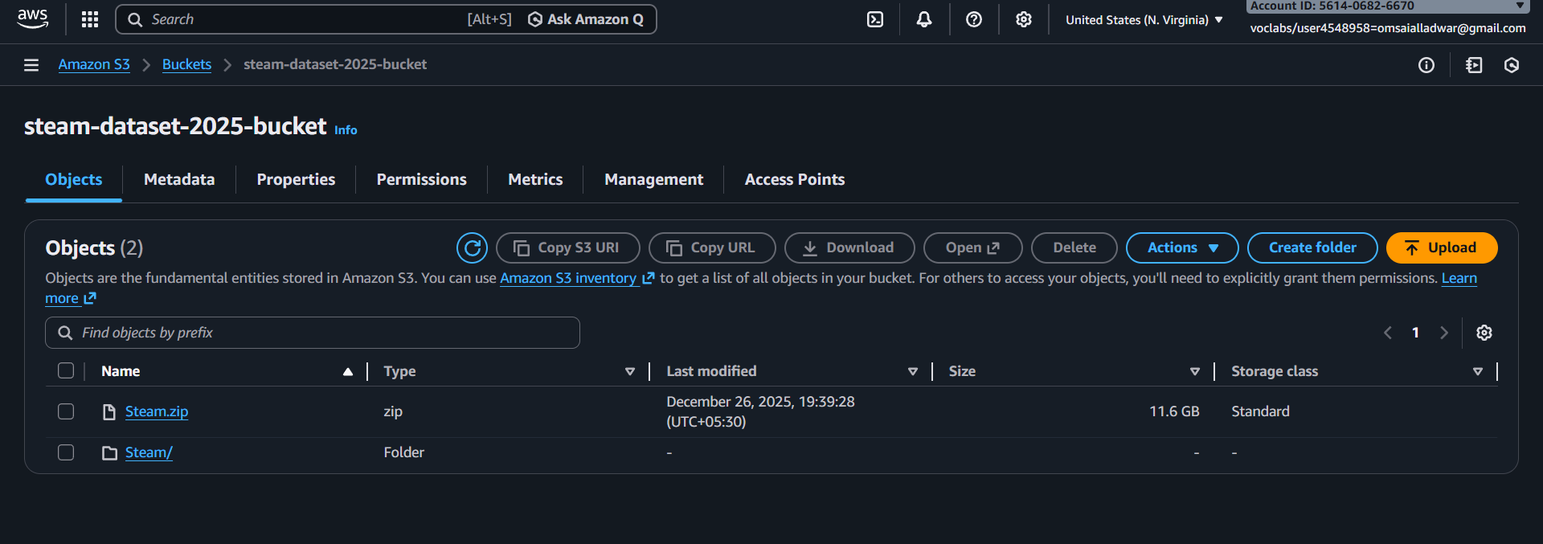
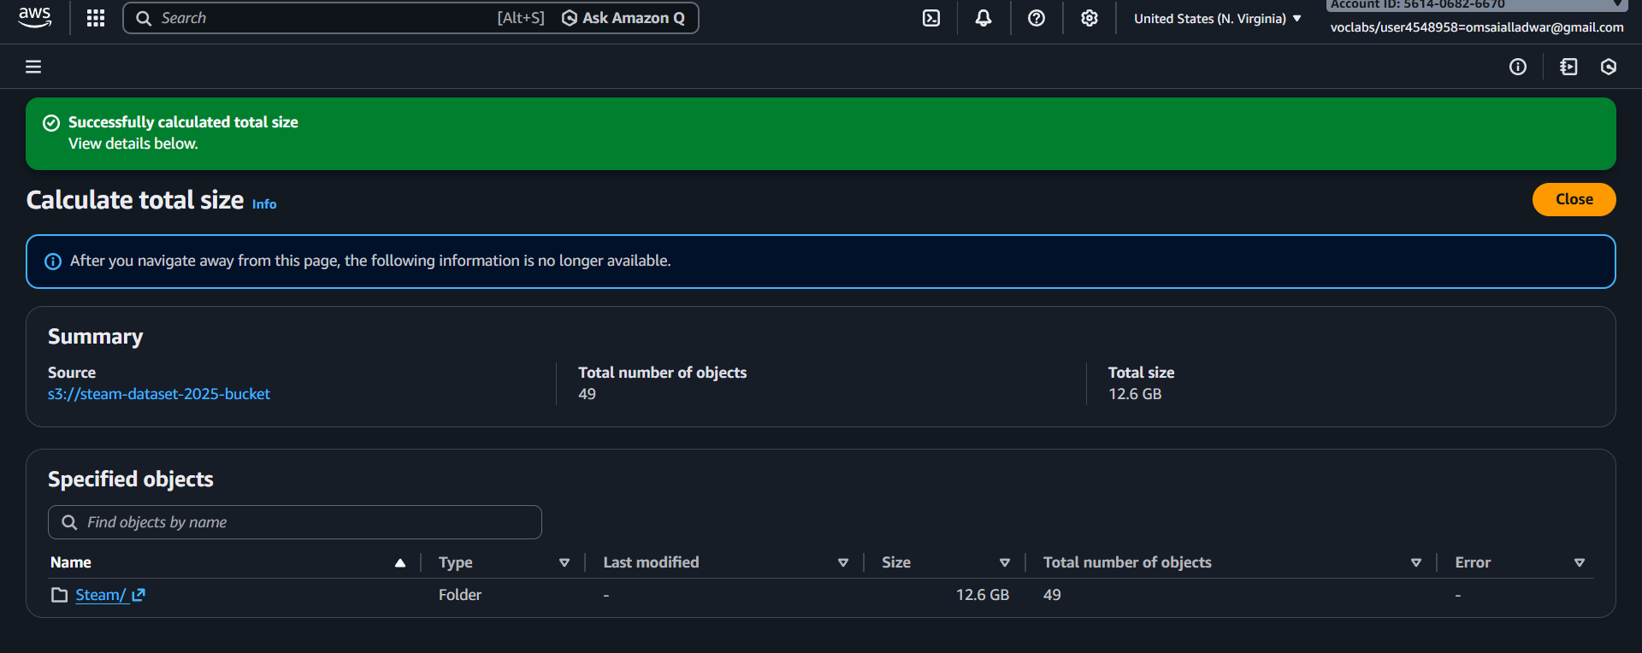

Cloud-Native Data Pipeline (Kaggle to AWS S3)

1. Problem Statement
The objective was to migrate a 12 GB dataset (containing 4 folders compressed in a ZIP file) from Kaggle to an AWS S3 Data Lake.
- Constraint: The available compute resource was an AWS EC2 t3.micro instance with only 8 GB of EBS storage (approx. 5 GB usable).
- Challenge: Standard download methods failed because the dataset size (14 GB) exceeded the available disk space (5 GB), causing immediate "Disk Full" crashes and termination of file transfers.

2. Solution Architecture
Instead of upgrading hardware (which incurs cost), we implemented a Zero-Disk Streaming Pipeline. This approach treats the EC2 instance as a "stateless bridge" rather than a storage container. Data is streamed through the RAM buffers without ever being written to the EC2 hard drive.

3. Implementation Steps

Phase 1: Direct Ingestion (Stream-to-S3)
We bypassed the local file system entirely by creating a Python streaming script using boto3 and requests.
- Mechanism: The script opens an HTTP stream to Kaggle's servers and pipes chunks of data (bytes) directly to an S3 multipart upload stream.
- Outcome: The 14 GB .zip file was successfully moved to S3 (s3://bucket/raw_data/) while using 0% of the EC2 disk space.

Phase 2: In-Memory Extraction (S3-to-S3)
To handle the 4 folders inside the zipped file without downloading it, we utilized the s3fs (S3 FileSystem) library.
- Mechanism:
  - Mounted the S3 bucket as a virtual file system in Python.
  - Opened the remote .zip file directly from S3 (reading the Central Directory).
  - Iterated through the 4 internal folders.
  - Streamed each specific file from the Zip source (in S3) to the destination folder (in S3) via RAM.
- Outcome: The raw data was transformed into accessible files (s3://bucket/extracted_data/) efficiently.

4. Technical Advantages
This methodology demonstrates advanced Data Engineering principles compared to standard "download-and-upload" techniques:

Feature | Standard Approach | Our "Streaming" Approach
Disk Usage | 14 GB+ (Crash on t3.micro) | 0 GB (Works on any instance)
Cost | High (Requires t3.medium or larger volume) | Low (Free Tier t3.micro)
Speed | Slow (Write to disk Read from disk) | Fast (Network Network)
Scalability | Limited by hardware size | Unlimited (Can handle 1TB+)

5. Technologies Used
- Compute: AWS EC2 (t3.micro, Ubuntu/Amazon Linux)
- Storage: AWS S3 (Simple Storage Service)
- Languages: Python 3
- Libraries: boto3 (AWS SDK), requests (HTTP), s3fs (Filesystem Interface), zipfile.

